Quantitative Risk Assessment

Single loss expectancy (SLE): Total loss expected from a single incident
Annual rate of occurrence (ARO): Number of times an incident is expected to occur in a year
Annual loss expectancy (ALE): Expected loss for a year

ALE = SLE X ARO

Safeguard value: Cost of a safeguard or control

Scenario 1: Richman Investments provides high-end smartphones to several employees. The value of each smartphone is $500, and approximately 1,000 employees have these company-owned devices. In the past year, employees have lost or damaged 75 smartphones.

With this information, calculate the following:
SLE | 500
ARO | 75
ALE | 37,500

Richman is considering buying insurance for each smartphone. Use the ALE to determine the usefulness of this safeguard. For example, Richman could purchase insurance for each device for $25 per year. The safeguard value is $25 X 1,000 devices, or $25,000. It is estimated that if the insurance is purchased, the ARO will decrease to 5. Should the company purchase the insurance?

Determine the effectiveness of the safeguard (fill in blank boxes):
Current ALE | 37500
ARO with control | 5
ALE with control | 2500
Savings with control (current ALE - ALE with control) | 35000
Safeguard value (cost of control) | $25,000
Realized savings (savings with control - safeguard value) | 10000

Should Richman buy the insurance? Explain your answer.

Yes, Richman should buy the insurance. The realized savings of $10,000 indicate that the cost of the safeguard ($25,000) is significantly less than the financial benefit gained from reducing the annual loss expectancy.

Qualitative Risk Assessment
Probability: The likelihood that a threat will exploit a vulnerability. Probability can use a scale of low, medium, and high, assigning percentage values to each.
Impact: The negative result if a risk occurs. You can use low, medium, or high to describe the impact.
You can calculate the risk level using the following formula:

Risk Level = Probability X Impact

Scenario 2: Richman Investments is concerned about the security of its customer data. Management has determined that the three primary risks the company faces in protecting the data are as follows:
- Unauthorized access by an external party
- Sabotage by an internal employee
- Hardware failures

Richman has created scales for the probability and impact of risks as follows:
- Probability: Low = 10%, Medium = 50%, and High = 100%
- Impact: Low = 10, Medium = 50, and High = 100

After surveying key individuals in the company, Richman calculated the probability and impact of each risk, as shown in the table below. Based on the information given above, calculate the risk level for each risk:

Category | Probability | Impact | Risk Level
Unauthorized access by an external party | 25 | 50 | 1250
Sabotage by an internal employee | 75 | 100 | 7500
Hardware failures | 30 | 25 | 750

Which risk has the highest risk level?

Sabotage by an internal employee has the highest risk level at 7500.

Prioritize the risks from high to low:
Priority 1 | Sabotage by an internal employee (Risk Level: 7500)
Priority 2 | Unauthorized access by an external party (Risk Level: 1250)
Priority 3 | Hardware failures (Risk Level: 750)
Present the data graphically to senior management in the form of a risk matrix. A sample risk matrix is shown below:

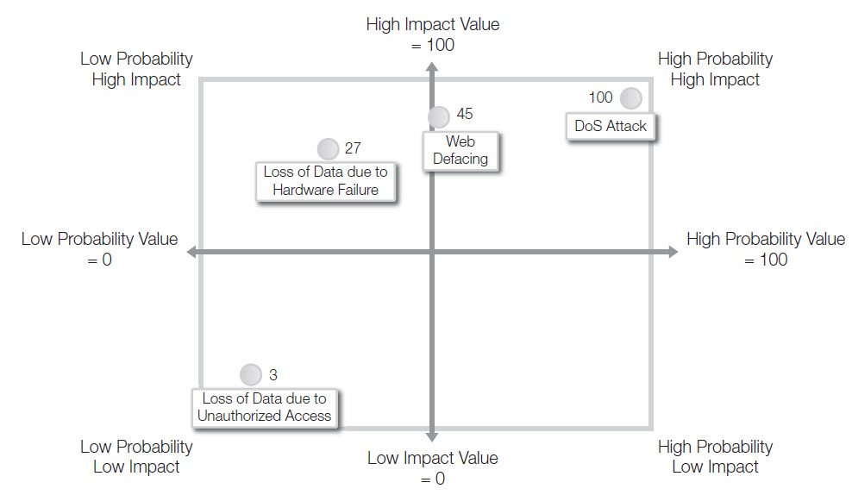

Complete the following risk matrix based on your data:

High Impact value = 100

Low Probability High Impact
High Probability High Impact
Sabotage by an internal employee

Unauthorized access by an external party

Hardware failures

Low Impact Value = 0
Low Probability
Low Impact
High Probability Low Impact
Low Probability Value = 0
High Probability Value = 100

